Our Ref.  Fax No.  Tel No. | : YMT RN 22001234  : (852) 2375 2397  : (852) 3661 8351 | 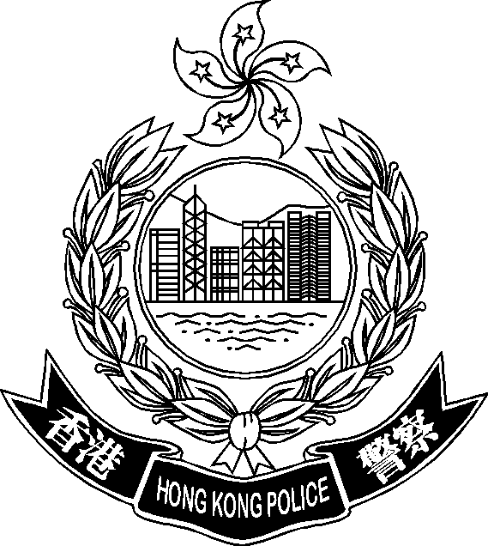
2022-08-03

To whom it may concerns,

Request for suspending suspicious “Whatsapp” account

Officers of District Investigation Team 1 of Yau Tsim District is investigating a case of “Obtaining Property by Deception” under our reference YMT RN 22001234.

Our investigation revealed that the “Whatsapp” account(s) below has/have been used by swindlers in defrauding victims’ money. The said account(s) is/are remained active as of the moment this letter is being written. The Hong Kong Police therefore urges your company to suspend the said account(s) immediately to avoid the recurrence of similar events.

Suspicious “Whatsapp” account(s)
(a) 44608456
(b) 89663542
(c) +4465448397

Should you have further enquiries regarding the request, please feel free to contact the undersigned, Officer-in-Charge of the case, at 3661 8351.

Thank you.

Yours faithfully,

( OC name )
for Commissioner of Police

